**~~~~~~~~~~~~~The Road to Newton: The Law of Universal Gravitation ~~~~~~~~~~~~~~~~**

**The Scientific Revolution**

33

Section

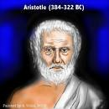

1. What was Artistotle’s concept of the universe, as interpreted by medieval Christian theologians?
2. What did Ptolemy add to Aristotle’s view of the universe?
3. What was the Copernican concept of the universe?
4. Briefly describe Brahe’s contribution.

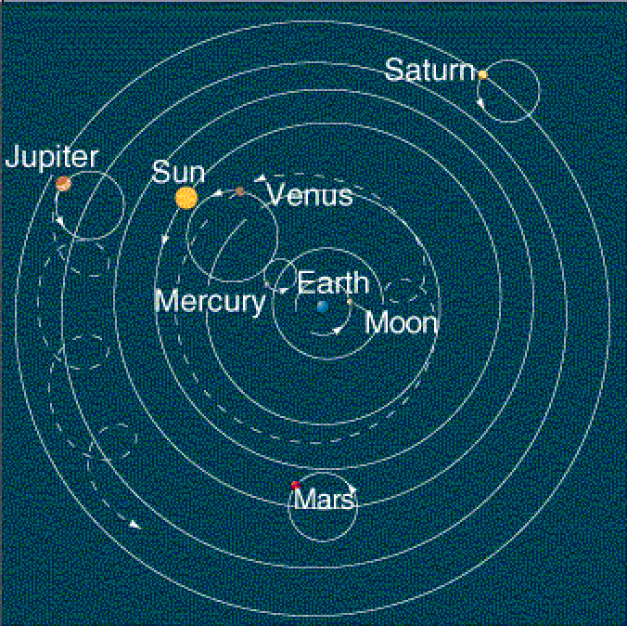

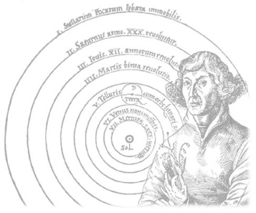

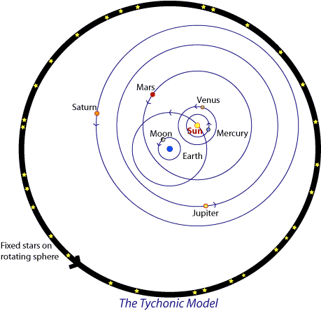

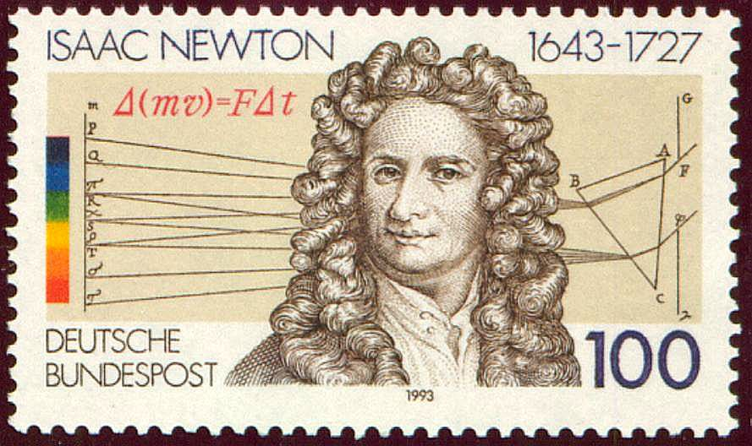

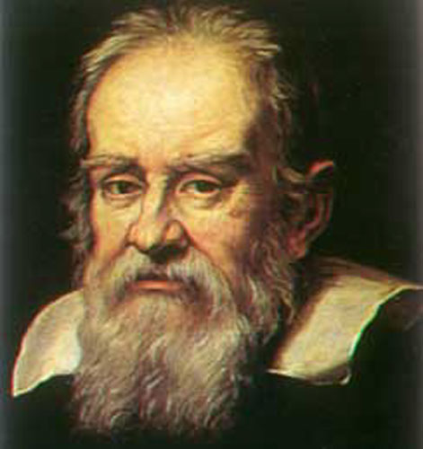

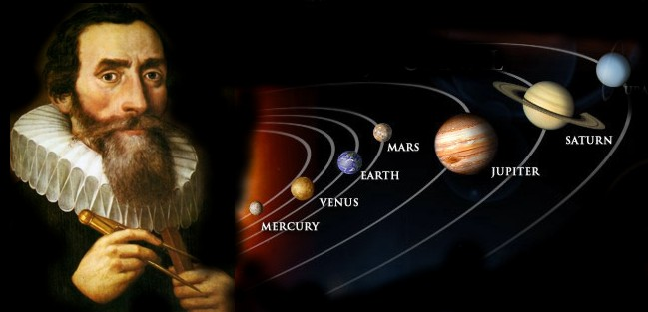

1. Briefly describe Kepler’s contribution.
2. Briefly describe Galileo’s contributions.
3. How did Newton synthesize the achievements of the Scientific Revolution?

**Principles of Natural Philosophy:**

1. Briefly describe Brahe’s contribution.

**~~~~~~~~~~~~~The Road to Newton: The Law of Universal Gravitation ~~~~~~~~~~~~~~~~**

**The Scientific Revolution**

33

Section